**Proposed Level of Achievement:**

**Apollo**

**Team name: planNUS**

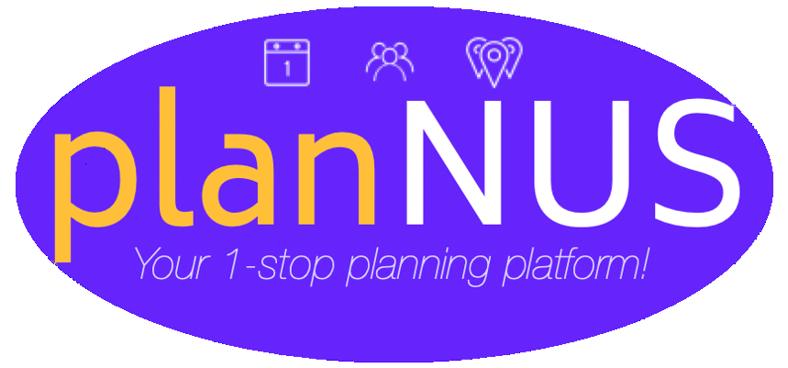

**Motivation:**

Given the age where we have a wide **range** of classes and events to attend, keeping track of events which we have to attend can be a burden on the memory. Sometimes, we also fail to **prioritise** our schedule properly. In addition, the hectic lifestyles make it difficult for us to find **common** free time together, whether it is for leisure activities or a formal meeting. It is also a hassle to manually look for free time with someone.

**Aim:**

We aim to make event planning easy for students and academic staff by giving them in-depth info about events relevant to them as well as proffering them suggestions on what they could do as well as expediting the process of organising mutual events among themselves. In addition, we aim to ease the process of finding mutually convenient time with any user of the application.

**User stories:**

1. As a user (student or staff), I want to be able to enter all my events on an application that helps me to keep track of events on a calendar and rank them according to priority or necessity, hiding away personal events from the public
2. As a user, I want to be automatically given reminders for their first, important and last event of the day as well as the directions to their event location (if they don’t know)
3. As a user, I can access in-depth information about the event location and number of people attending, as well as to rate the events themselves i.e tutorials, classes, food quality at stalls etc, and those ratings can be made public for all app users.
4. As an academic staff, I can upload relevant content to their event on the cloud for event attendees to access if permissible
5. As a user, I can use live messaging services and timetable sharing to make available my public schedule to other users
6. As a user, I can get recommendations on what I can do individually/with my friends, which is generated based on the live activity of the people near them
7. As a user, I can request for a meeting with another user or a group of users.
8. Also, as a student, I can request for a consultation slot with an academic staff

**Features and Timeline:**

A **mobile application on either iOS/ Android** is used to store and display students’ events for the day/week/month.

**Amazon Web Services(AWS)** is used to store the data of students on cloud, as well the comments and ratings of the events they attended

**Google Maps** is used to approximate the locations of students.

**Collaborative and content-based recommender systems** are to be used in generating good recommendations for students to do either alone or with their friends on the occasion where they are free.

Features to be completed by the mid of June:

1. Mobile app
   1. Store and display an interactive view of a person events’ schedule for the day
   2. Display the timetables of their friends as well and generate notifications on the occasions their friends are done for the day/joining their events
   3. Inbuilt reminder systems for first, important and last events
   4. Location services to store the exact locations of student events
   5. Request meeting from a list of time slots when all participants of the meeting are free
2. AWS
   1. Store data of the students on the cloud
   2. Store data of the information and quality of students’ events

Features to be completed by the mid of July:

1. Event Recommender systems with machine learning
2. Live in-app messaging services
3. Interactive frontend systems for the display of events ratings, comments and additional information regarding those events
4. Simple gamification system of active users that contribute to the information collection of the application by evaluating and providing accurate information about events and uploading additional material related to the event.

**Tech Stack:**

1. Flutter
2. Android Studio
3. Firebase
4. AWS
5. Python

**Qualifications**

* Equipped with Functional programming, Object Oriented paradigm, Data Structures
* Team is comfortable with HTML/CSS/Javascript/Java/Python
* Have experience working with Unity/C#
* Hack N Roll (Made a telegram bot)

Poster Pitch Minute Madness

Hello everyone, we are team PlaNUS. We are working on this planner application that helps us keep track of our schedule and facilitates the ease of finding common free time between users. Being University students ourselves, we all have many different projects in different modules. From our experiences, having project meetings can be a hassle because we all have the freedom to choose our own schedule and have different lesson time. Thus, we came up with the idea of this planNUS app that allows us to store our timetable and meet function that shows the free time between users. You don’t have to fill in google doc forms for booking of consultations anymore!

We will also help to prioritise events according to its importance for you. We note some tutorials or lectures are not compulsory and we want to show it in the app so that we can focus on more important stuff that needs to be completed.

When our day ends early or we have a long break, we may want to do something to fill in the blanks. Thus, our app will help to recommend activities nearby for you to enjoy!

Hello all! Welcome to planNUS! Before we start, I just want us to pause for a second and think. Has event planning ever been easy for you? **Since** stepping foot into NUS, has there **ever** been a single solitary day whereby we don’t have to scroll through Telegram, Calendar, NUSMods and a thousand other apps to check if we can schedule an event? If your answer to both questions is no, planNUS is here to help! planNUS is a 1-stop planning platform that harnesses the functionality of the relevant applications involved in our short-term or long-term event planning. It also features several useful added functionalities that aspires to make event planning a breeze for all.

You can store any events in your schedule and rate the events after going through them. planNUS can also help you to prioritize your events. On top of that, planNUS can also help you to schedule meetings with peers or consults with academic mentors on-the-fly, without relying on emails or google forms.

The planNUS app allows us to store our timetable and meet function that shows the free time between users. You don’t have to fill in google doc forms for booking of consultations anymore!

We will also help to prioritise events according to its importance for you. We note some tutorials or lectures are not compulsory and we want to show it in the app so that we can focus on more important stuff that needs to be completed.

When our day ends early or we have a long break, we may want to do something to fill in the blanks. Thus, our app will help to recommend activities nearby for you to enjoy!

Hello all! Welcome to planNUS! Before talking about planNUS, I just want us to pause for a second and think. Has event planning ever been easy since stepping foot into NUS? Amidst the mountain of activities, assignments and exams we have been forced to pull through, has there ever been a solitary day whereby we don’t have to trawl through Telegram, Calendar, NUSMods and a thousand other apps to check if we can schedule any event? Obviously, its sure damn impossible! Here, thanks to the beautiful interplay between Flutter, FIrebase, Python, planNUS allows you to store any type of events and then order, rate at your own disposal. All of us have lessons that are not compulsory and hence here at planNUS, we generate timetables that takes into account the priority of your events. On top of that, planNUS gives u the power to schedule meetings with academic mentors/peers on-the-fly, without relying on emails/additional texting to do so. Additionally, when you’re free, u could always explore the other events happening around you, all of which is specially handpicked by our world-class machine learning algorithms.